**Title of the Paper**

[Font Calibri, Size 12, Centre, bold, no italics]

**Abstract**

[Font Calibri, Size 11, line spacing 1.5, Left aligned (Do not justify), no underlining, or quotation marks]

An abstract is a summary of the article. It should be a single paragraph with 200 – 250 words. It should follow the style of structured abstracts **but without headings**. You must include 1) Background and the research question(s) addressed; 2) Methods: Briefly describe the main methods or treatments applied. Include any relevant sample/participant/species information; 3) Results: Summarise the article's main findings; and 4) Conclusion: Indicate the main conclusions or interpretations. The abstract should objectively represent the article. Do not include any results that are not presented and supported in the main text. The abstract should not exaggerate the main conclusions. Avoid quotations and citing references in your abstract.

***Keywords:*** Maximum five keywords. Each keyword must be separated by a semicolon.

(Example: First keyword; Second keyword; Third keyword)

**Introduction**

[Font Calibri, Font size 11, line spacing 1.5, Left aligned - Do not justify]

The purpose of the introduction is to stimulate the reader’s interest and to provide background information relevant to the study. Explain the broad theme/topic of your study in an opening paragraph in such a way that the reader can clearly understand what the study is about. Explain the academic and practical importance of the study. Compile the available literature by synthesising the existing knowledge instead of summarising and citing the most important previous studies which are directly relevant to your research problem. Highlight the important gaps and inconsistencies based on the existing literature, which needs further investigation. If it is relevant specify the objectives of your research with no more than three objectives.

**Materials and Methods**

This section describes in detail how the study was conducted, including important definitions used in the study. The research design, sampling methods, methods of data collection, and analysis should be given in this section.

**Results and Discussion**

Use a separate results section. Split this section into several sub-sections directed by subheadings to improve readability. Before writing this section, it is important to plan which results are important to the relevant study and which can be left out. Results can be shown either in Tables or Figures. Data in tables and figures should not be duplicated. After presenting the results, carefully evaluate and interpret their implications for the objectives of the study.

**Conclusion/s**

This section summarizes the conclusions that can be drawn from your study. The main conclusion/s should be presented first followed by any other minor conclusions in decreasing order of importance. In this section, you may also emphasize the contribution of your study to the betterment of humanity.

**Acknowledgement**

Briefly acknowledge any funding, administrative and technical support, or donations in kind (e.g., materials used for experiments).

**References**

* A maximum of 15 references can be included at the end of the paper.
* The reference list must be in line with the **APA 7th edition** style of referencing for all the tracks except the papers submitted to the **Law track** in which **OSCOLA Referencing 4th edition** shall be used.

# General Formatting instructions

* **Font:** Calibri 11, 1.5 line spacing, Left Aligned
* **Margins:** Use 1-in. margins on every side of the page.
* **Levels of Headings**: One to three levels of headings will be sufficient.

The first three levels are set up as follows:

**Level 1**: Left align, Bold, Title Case Heading Text begins as a new paragraph

**Level 2**: Left align, Bold, Title Case Heading Text begins as a new paragraph

**Level 3**: Left align, Bold Italics, Title Case Heading Text begins as a new paragraph

* **Footnotes**: should be avoided. When their use is necessary; number them consecutively using Arabic numerals. Type at the bottom of the page to which they refer. Place a line above the footnote, so that it is set off from the text. Use the appropriate superscript numeral for citation in the text.
* **Columns:** 2 Columns, Width 3”, Spacing 0.5”

[**Note**. The maximum number of pages for the conference paper is **Eight**]

* Short quotations within the text should be marked with double quotation marks: Lawson also has a broad understanding of design when he mentions: “Professional designers such as architects, fashion designers and engineers” (Lawson, 2004, p.5). Longer quotations of more than one line should be formatted as below, again within double quotation marks:

“More of the goods and services produced for consumer across a range of sectors can be conceived of as ‘cultural’ goods, in that way they are deliberately inscribed with to generate desire for then amongst the end uses sold to consumers in terms of particular clusters of meaning indicates the increased importance of ‘culture’ to production circulation of a multitude of goods and services.” (du Gay, et al, 1997, p.24)

* **Language**

Please use either British or US, spelling but not a mix of the two.

* **Page Numbers**

Please add page numbers at the bottom of each page.

* **Acronyms**

All acronyms should be spelt out the first time they are introduced in text or references. Thereafter the acronym can be used if appropriate, e.g. 'The work for the Organization of United Nations (OUN)...'. Subsequently, 'The OUN studies on...', in a reference ... (Organization of United Nations [OUN] 1989).

* **Equations, tables, and figures**

Equations must be written preferably with the same word processor used for the rest of the text, without handwritten symbols to aid legibility. Equations must be numbered sequentially with their numbers in parenthesis and right aligned.

Tables and figures must be embedded in the paper text, close to the location of their first appearance. All tables and figures must be referred to in the text as follows: Figure 1, Table 1, i.e. 'As seen in Table [or Figure] 1 ...' (not tab., fig. or Fig). All figures must be numbered in the order in which they appear in the paper (e.g. Figure 1, Figure 2). Please ensure that tables do not split over the page.

* **Titles of tables and figures**

Each table should have a descriptive title and each column should have an appropriate heading. Figure captions should be placed below the figure and should be typed separately.

Tables should be formatted as Table 1 (below): column headings - centered. Only horizontal table grid lines should be used.

***Table 1*.**The heading of the Table should be written on top of the table.

|  |  |  |
| --- | --- | --- |
| **Table Rows** | **Cell one** | **Cell two** |
| Second Row | 1 | 2 |
| Third Row | 2 | 3 |
| Fourth Row | 4 | 5 |

* **Use of Visual Material**

Where possible please make images:

Large enough to see clearly;

Of good resolution (200dpi);

Optimised to be less than 350Kb;

Cropped appropriately.

If you are using diagrams, infographics, or other schematics please ensure that:

You present information clearly;

You use the Calibri font;

All text is legible;

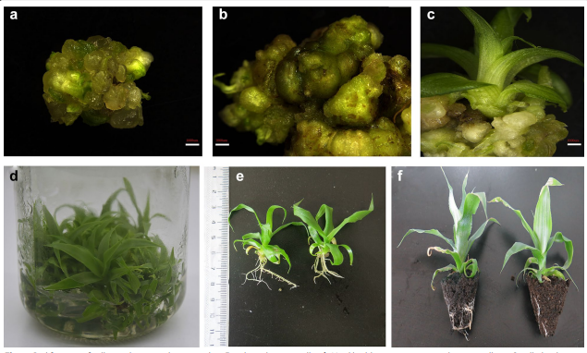

**Figure 1.** Proliferation of callus and in vitro plant growth. a) Fragile embryonic callus. b) Hard highly compact non-embryonic callus. c) Small plantlets start to grow from embryonic callus. d) Well-grown callus with small plantlets after 1 month. e) Plants grown in MS liquid medium for 1 month. f) Acclimatized in vitro grown plants. Bar in a–c=1000 μm

(Captions are placed under the figures. Ensure that your caption adequately describes what you want your reader to see in the figure, highlighting any areas that they should focus on or the relationships that you might want them to see).